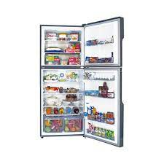

GR-E9978G

* Voltage As Low As 125V
* Cooling 5 Different Directions
* Color Grey
* Direct Cool Everest Series
* **Rs.82,000**